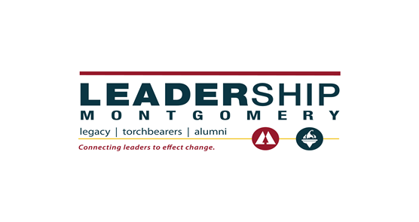
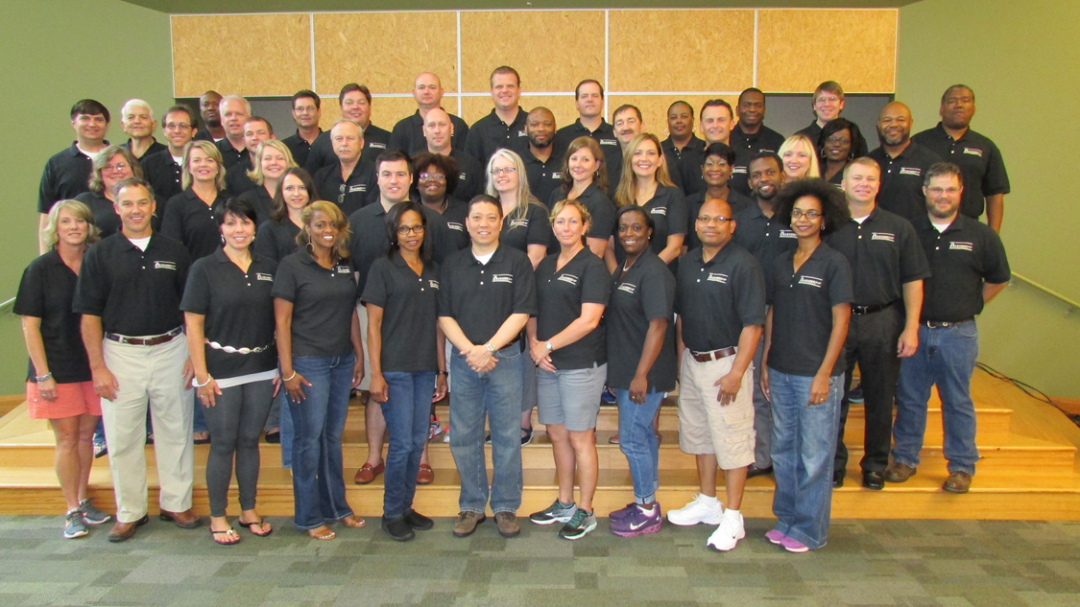
Legacy Class XXXII
Community Project Presentations
Thursday, May 5, 2016

www.leadershipmontgomery.org
334.262.2261
LEGACY CLASS XXXII PROJECT TEAM ONE
COMMUNITY SCHOOLS PROJECT AT
DAVIS & E.D. NIXON ELEMENTARY SCHOOLS

CHAIRPERSON: Greg Barnes
TEAM MEMBERS: Bernard Houston, Bryan Kelly, Melanie Lane, Karen Laneaux, Dean Peevy, Lisa Townsend and Robert Wheat
THEMATIC AREA: Education and Quality of Life
DATE(S) OF IMPLEMENTATION: August 2016-May 2017
DURATION OF THE PROJECT: Ongoing during each school year.
PROJECT LOCATION: E.D. Nixon Elementary School, 100 Edgar D. Nixon Blvd. Montgomery, AL 36104 and Davis Elementary School, 3605 Rosa Parks Ave. Montgomery, AL 36108
FINAL PROJECT DESCRIPTION: The term “community schools” is used to describe the concept of school-community initiatives that encompass a vast array of programming tailored to support multiple domains in the education and development of students. According to research conducted by the Children’s Aid Society, (2001) , “Youth need supports in cognitive, social, emotional, physical, moral, and vocational domains in order to reach productive adulthood, which is defined as having skills that will allow for participation in the labor economy, a responsible family life, and an active citizenship.” Children’s Aid Society. Building a Community School. Third Edition, 2001.
We worked closely with the Montgomery Public Schools’ Community Schools Director, Camille Anderson-Finley, to design a project utilizing community resources to promote student development. Our project addresses the schools’ need for social workers and mental health counselors on a consistent basis. We will utilize college interns who will provide counseling and mental health services at E.D. Nixon and Davis Elementary. Previously, the two schools shared one social worker whose services were grant funded. Losing the grant resulted in losing the social worker. The need, however, continued. Non-academic home-life issues disrupted the daily academic environment, interfering with the students’ abilities to learn and perform at their full potential. Rather than dedicating the necessary time to teaching, teachers and administrative staff were consumed with addressing the students’ various family crisis issues including, but not limited to, hunger, homelessness, mental health and substance abuse.
Team members were individually tasked with contacting specific universities and community resources. Alabama State University, Faulkner and Troy University have agreed to provide college interns at the elementary schools. After contacting Alabama State University, we learned our project is revitalizing a previously defunct collaboration between Alabama State University and Davis Elementary. Our project allows Alabama State University to build off that former agreement. In order to establish longevity, our team project shall be incorporated within the newly established Montgomery Public Schools’ Community Schools program, which will provide the structure and consistency necessary to maintain and grow this project.
PROJECT TEAM ONE (continued:)
After meeting multiple times with Faulkner University, we determined that we could establish a partnership with Faulkner’s mental health counselor program. With a new partnership with Common Ground Montgomery, we were able to identify a staff member at Common Ground with a master’s degree in counseling who is qualified to oversee and supervise the college interns placed at E.D. Nixon. The program will place 3 to 5 college students at E.D. Nixon serving under the Common Ground Montgomery supervisor and the school principal. Among a broader scope of services, the college students will focus on crisis intervention, conflict resolution, anti-bullying, social media training, and group leadership training. The intern-provided services should free up the principal and the guidance counselor, allowing them to focus on the students’ academic and social success.
In addition to providing college interns, our group also participated in the Career Day programs at each school. Career Day is another example of community volunteers working within the schools to promote student development. Our team members provided career exposure in the areas of banking, computer science, law, human resources management, ministry and charitable non-profit organizations.
MEDIA OUTLETS CONTACTED: N/A
WHO WAS SERVED AND HOW MANY PEOPLE BENEFITED?
E.D. Nixon’s student enrollment is approximately 435. Davis Elementary has approximately 486 students. Currently, the after school program serves approximately 40 students at each school.
OTHER AGENCIES AND GROUPS WHO WERE INVOLVED:
Montgomery Public Schools’ Director of Community Schools: Camille Anderson- Finley. This project would not have been possible without Mrs. Finley’s tireless efforts to improve services provided to our children.
Also, Alabama State University School of Social Work, Faulkner University and Troy University
VISION FOR THE FUTURE OF THE PROJECT:
The Montgomery Public Schools System Director of Community Schools, Camille Anderson-Finley, hopes this project will become a staple within the Community Schools program. With strategic planning, the program at these specifically targeted schools will improve each year. With ongoing success at these two schools, the program could then expand to the other schools within MPS. It is our hope that future Leadership Montgomery classes will continue to partner with the Community Schools program, develop additional services and expand this project to more schools.
WILL THIS BE AN ONGOING PROJECT OR WILL IT BE A ONE-TIME PROJECT?
This is an ongoing project scheduled to launch in school year 2016-2017 and continue thereafter.
IF IT WILL BE ON-GOING, WHO WILL CARRY THE PROJECT FORWARD?
The Montgomery Public Schools’ Community Schools Program.
PROJECT TEAM ONE (continued:)
DESCRIBE EXACTLY HOW YOUR PROJECT WAS IMPLEMENTED:
Individual team members contacted each local university and identified those schools with the relevant curriculum that could provide the interns necessary to fulfill the elementary schools’ particular needs. Once the team identified the appropriate school curriculum, the team identified the supervisor necessary to supervise the college interns. This was perhaps the most time-consuming and challenging issue. Team members used personal and professional networks to identify those persons needed to accomplish this project. The MPS Director of Community Schools and MPS Director of Student Support Services then defined the specific scope of services for each university.
This project involved partnering with Alabama State University’s School of Social Work, Faulkner University and Troy University. The universities agreed to provide either graduate level or undergraduate level student interns for each elementary school. The college interns, under the direct supervision of the appropriately licensed professional, will provide on-site services to the elementary school students. Alabama State University shall provide undergraduate social work services at both schools and supervise them as necessary. Faulkner shall provide undergraduate mental health services at E.D. Nixon. Common Ground shall provide off-site supervision for the E.D. Nixon interns. E.D. Nixon’s current school counselor shall supervise the interns on-site. Troy University shall provide graduate level mental health and counseling at Davis Elementary. The Davis Elementary school counselor and social worker shall supervise the Troy interns on site.
The respective college administrators, the Montgomery Public School System Department of Student Support Services, and the Montgomery Public School System’s Community Schools Director are finalizing the scope of services with each university.
The universities shall follow their interns within their current field placement programs, with interns receiving college credit towards required on-site service hours.
HOW MANY VOLUNTEER HOURS WERE DEVOTED TO THIS PROJECT?
Our initial meeting with Mrs. Finley was about one hour. Our team met with the school principals and with Mrs. Finley for approximately 1.5 hours. Thereafter, our eight (8) team members met as a group approximately eight (8) times for approximately one (1) hour. Individual members each dedicated approximately two (2) hours to their specific assignments. Preparing the final report and slide show consumed approximately four additional hours.
Team members spent an additional two (2) hours coordinating and or meeting with each university’s representative and the Director of Community Schools. A total of 84 hours was dedicated to finalizing this project.

PROJECT TEAM ONE - SCHOOL PHOTOS:
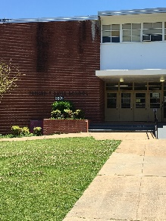 Davis Elementary School 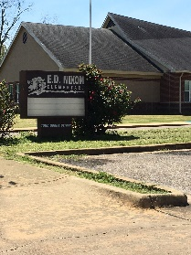 E.D. Nixon Elementary School

PROJECT TEAM ONE - CAREER DAY PHOTOS:

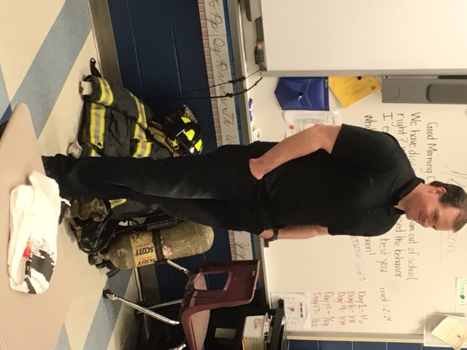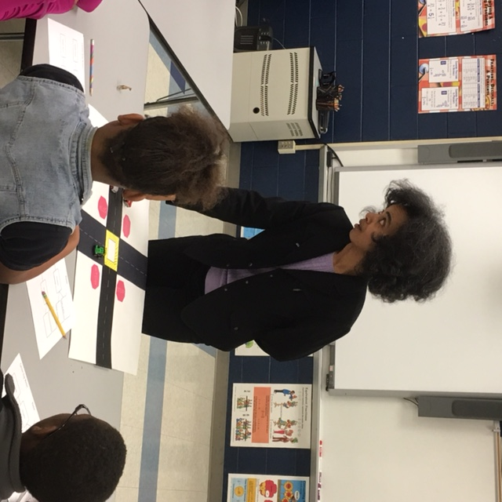
Team Member: Bryan Kelly Team Member: Karen Laneaux

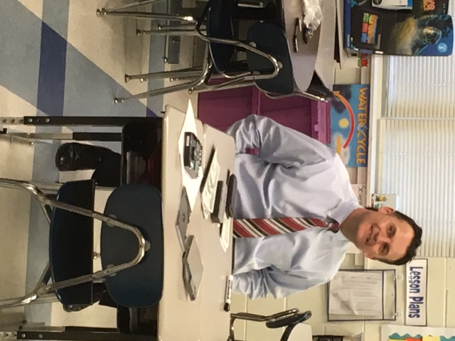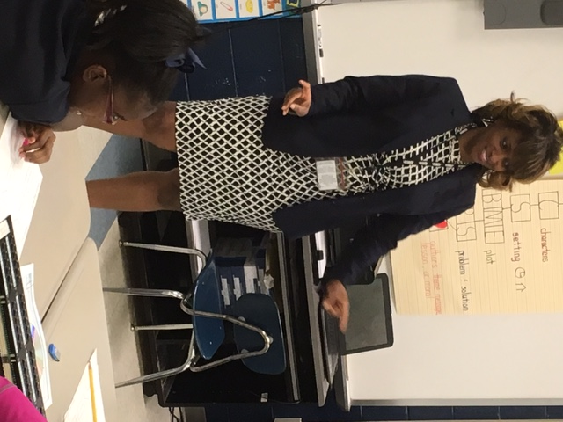

Team Member: Dean Peevy Team Member: Lisa Townsend
PROJECT TEAM ONE - CAREER DAY PHOTOS (continued):

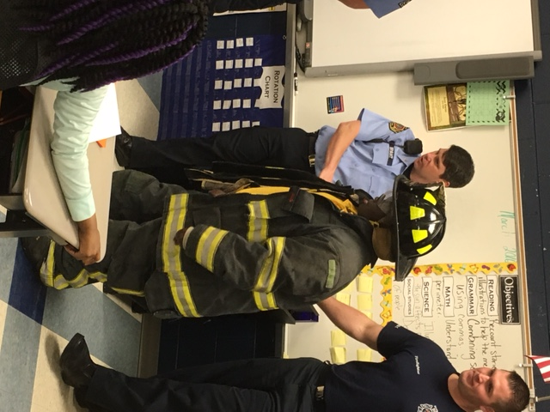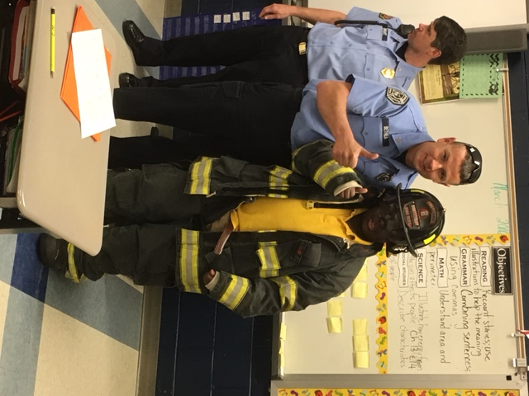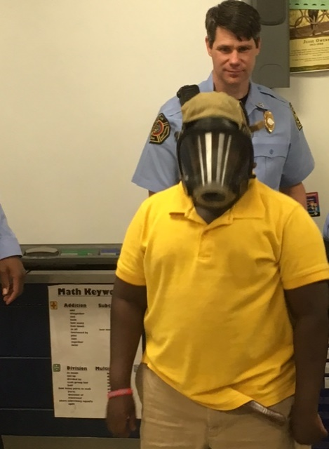

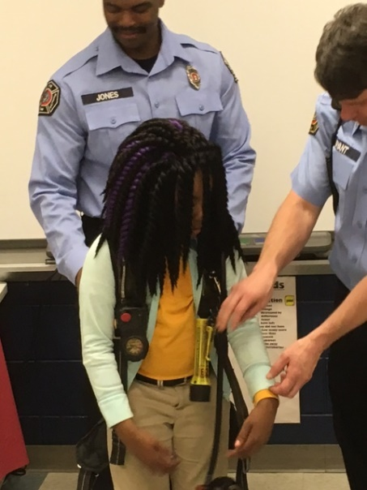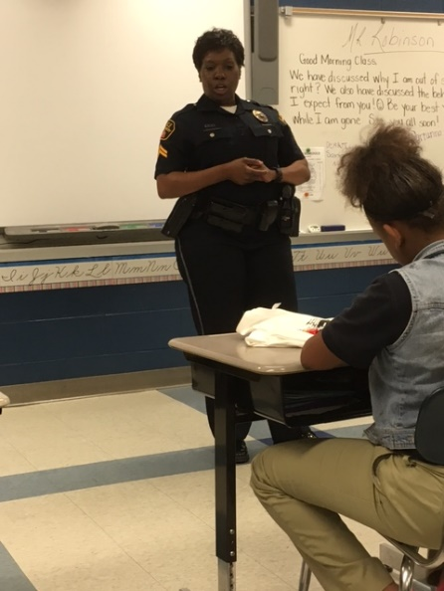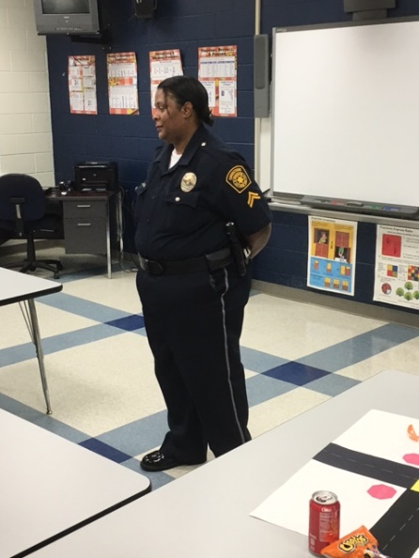

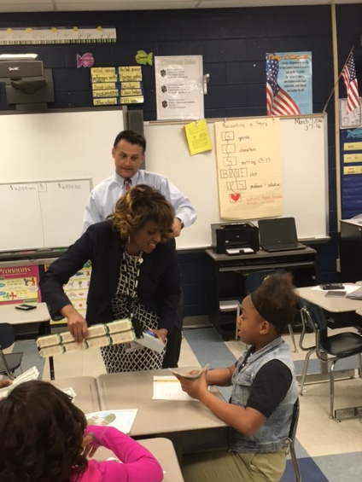
Team Members: Dean Peevy and Lisa Townsend
LEGACY CLASS XXXII PROJECT TEAM THREE

"PACK FULL OF HOPE,” THE BACK PACK PROGRAM
CHAIRPERSON: Susanne Trest
TEAM MEMBERS: Sheila Austin, Dennis Barnes, Jon Briggs, Cathy Duncan, Brantley Leverette, Leo Lewis, Susanne Trest, and Billy Whigham
THEMATIC AREA: Poverty/Homeless Children
DATE(S) OF IMPLEMENTATION: October 2015-April 2016
DURATION OF THE PROJECT: 7 Months
PROJECT LOCATION: Carver Elementary School, 3100 Mobile Drive, Montgomery, Alabama
FINAL PROJECT DESCRIPTION:
Our Mission: To obtain local support and funding that establishes and sustains a back pack program that will feed qualified children in local schools every week.
Our Goals:
* To solidify the Carver Elementary Program
* To work with Jackie Chappell, a volunteer and Mother of a Student at Carver, to learn about the program that was already in place (After realizing the struggles facing this program in this particular school, we developed other goals.)
* To fund the Program short term (for this year) and long term (for the next 20 years)
Our project committee made the decision to fund the program for the 2015-2016 school year. All eight (8) committee members donated approximately $200 each. We discovered that this Back Pack Program was in other schools, being supported by other organizations, including mainly churches. We then developed a list of churches around Carver Elementary School, which consisted of approximately sixty (60) churches. We narrowed that list down and decided that The City of St. Jude would be the best fit. Long term, we approached The City of St Jude and asked them to adopt the program, both physically and financially. Since fitting well into their mission, they gladly accepted.
* To create a Leadership Council; to help guide the program; to identify growth opportunities to expand current programs; to spread the program to the many other elementary schools that have the need for the program; and possibly to help pass along best practices. This group has agreed to try and meet quarterly going forward.
* To sustain the entire Back Pack Program
PROJECT TEAM THREE (continued):
* To work with the City of St Jude to provide Back Packs to approximately 50 qualified homeless children each week during the school year (and possibly more during the summers)
MEDIA OUTLETS CONTACTED:
Daryl Forbes, WAKA
WHO WAS SERVED AND HOW MANY PEOPLE BENEFITED?
Approximately 50 qualified homeless students of Carver Elementary School
OTHER AGENCIES AND GROUPS WHO WERE INVOLVED:
* Douglas Watson, Executive Director for The City of St. Jude, adopted the program and will support it for years to come.
* Jacqueline Chappell, a Carver volunteer and parent, had been managing the program with very little financial and physical support.
* Walnie Covington, Principal of Carver Elementary School, committed to allowing The City of St. Jude to adopt and support the program.
* Arica Smith, a Leadership Montgomery alumnae, helped introduce the project team to the program.
* Mona Davis, MPS Public Information and Marketing Manager, and Jolene Kearns, Montgomery Area Food Bank, were important in the two round table meetings we coordinated to help formalize a team community effort. Eleven churches/community organizations that support other Back Pack programs attended these meetings.
* Ramer Methodist Church helped implement this program at Anointed Warrior Hill Baptist.
* Bill Cunningham of the Cunningham Group helped design a marketing piece for the program.
* Tommy Nichols, Kwik Kopy Shop, printed the new marketing materials.
* The Central Alabama Community Foundation met with team members to discuss potential financial support.
* The Montgomery Education Foundation advised the team on fundraising and possible methods of running the money through its organization instead of through Leadership Montgomery.
* Wynlakes Golf and Country Club provided space for ALL Project Committee Meetings AND Round Table Meetings that sometimes included lunch.
* JB Enterprises, a graphic artist, helped the team with a Project 3 logo.

PROJECT TEAM THREE (continued):
VISION FOR THE FUTURE OF THE PROJECT:
The City of St. Jude shows great promise in assisting the homeless children enrolled in Carver Elementary in future years. They have the facilities, funding and volunteers to sustain this program. Other schools are in need of this program as well. Leadership Montgomery may need to consider going into other schools to obtain support.
WILL THIS BE AN ONGOING PROJECT OR WILL IT BE A ONE-TIME PROJECT?
For Carver Elementary, this is a one-time project for class XXXII, but with the assistance of St. Jude, the project may be on-going.
IF IT WILL BE ON-GOING, WHO WILL CARRY THE PROJECT FORWARD? The city of Saint Jude
DESCRIBE EXACTLY HOW YOUR PROJECT WAS IMPLEMENTED:
The Back Pack Program was already established at Carver Elementary School by an earlier Leadership Montgomery class and was continued with the assistance of a Leadership Montgomery alumnae and Mrs. Jackie Chappell. However, for the 2015 school year, we felt our job was to sustain funding and volunteers (aka-an organization) to support it.
During the year following Leadership Montgomery’s initial adoption of the program, Carver began to struggle to maintain it. It became a one-woman show, with Mrs. Chappell taking the lead; but when she became ill, the program ended. In April, The City of St. Jude adopted it, and the Project Three Committee breathed sighs of relief. We thank God for these children and The City of St. Jude.
HOW MANY VOLUNTEER HOURS WERE DEVOTED TO THIS PROJECT?
Collectively Project Team #3 worked 275 hours on this project.

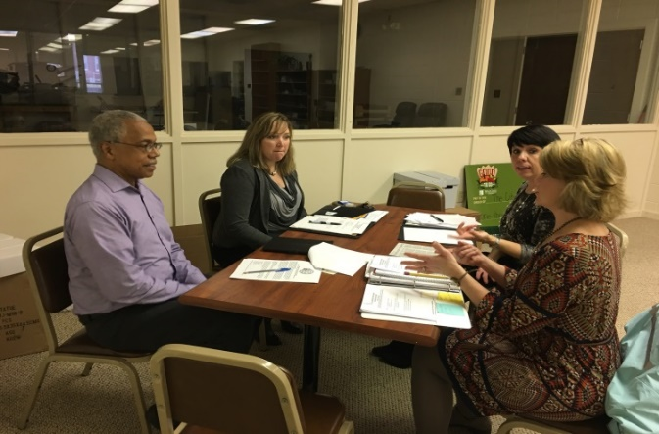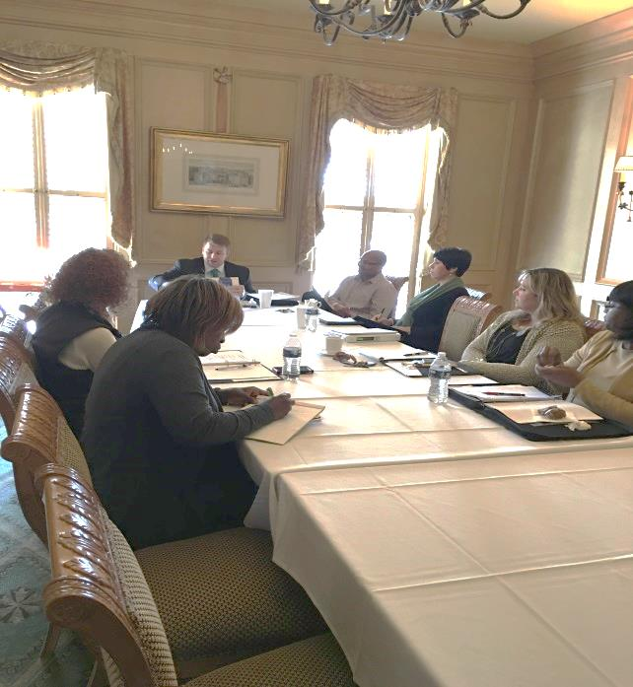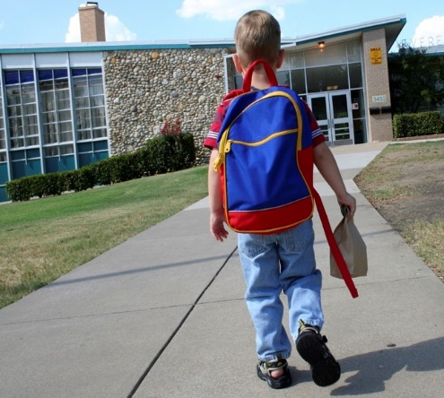

PROJECT TEAM THREE PHOTOS:
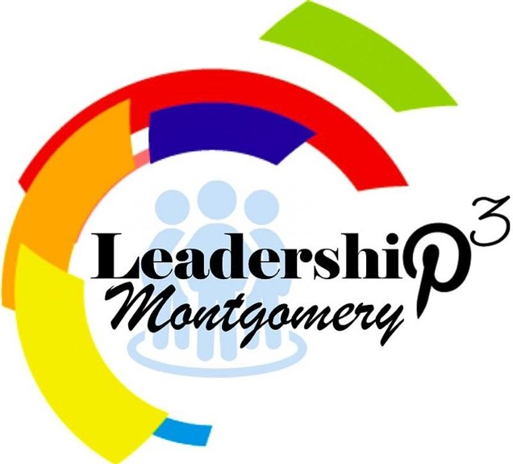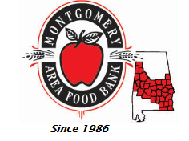

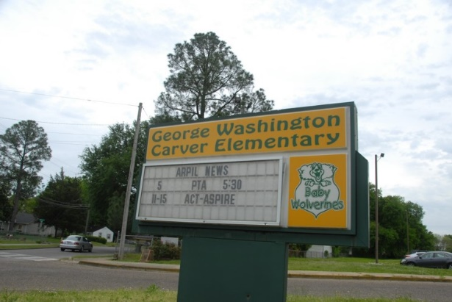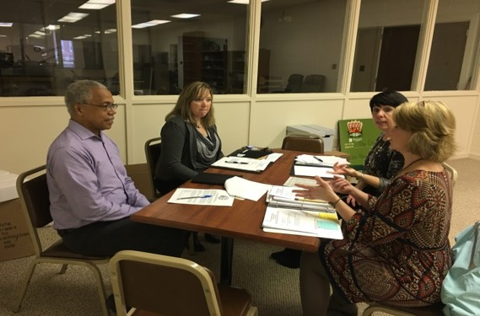
LEGACY CLASS XXXII PROJECT TEAM FOUR
STOP TEACH DETER
CHAIR PERSON: Barbara Wells
TEAM MEMBERS: Dr. Shantay Bolton, Jackie Davis, Melissia Carter-Duncan, Katya Gill, Robert Granfeldt and Clay Henley
THEMATIC AREA: Health and Criminal Justice Prevention
DATES OF IMPLEMENTATION: We were not able to implement the project as planned.
DURATION OF THE PROJECT: We worked toward implementation from August of 2015 through March of 2016.
PROJECT LOCATION: The project was designed to be presented in all 8 high schools in the Montgomery Public School System.
FINAL PROJECT DESCRIPTION:
Our area has disproportionately high rates of sexually transmitted infections. Statistics show that young people make up a large percentage of the infected population especially for HIV infections. Moreover, recent events highlight the prevalence of young people using electronic devices to make and distribute sexual images. This activity can result in life changing consequences. Not only can such conduct, like other sexual activity with underage persons, result in incarceration, but also such offenses can result in an individual having to comply with the restrictions placed on registered sex offenders for the rest of their lives. Knowledge is empowering. We hoped that this project might help the students better evaluate the potential adverse consequences of certain behaviors and decide to avoid such behaviors.
The project was designed to replicate a successful educational program implemented in Bibb County to help inform high school students in the 11th and 12th grades about the potential legal consequences, social, and health consequences of certain sexual behaviors. The goal was to provide information about the risk of exposure to sexually transmitted diseases; the consequences of teen pregnancy; the laws applicable to underage sexual activity; the laws applicable to sexting; and the adverse consequences of acquiring a sex offender label. Another goal of the project was to help better inform students so they can make better choices and to empower them with language to resist activities they have decided to avoid.
Although initially, we were encouraged by the willingness of various persons with DHR and local law enforcement agencies to be involved with implementing an educational program like the one implemented in Bibb County, support evaporated when it became clear that Montgomery Public Schools would not allow the sessions without sending home specific permission slips and that the content of the presentation must emphasize certain information. The Alabama Code § 16-40A-2 (1975) sets forth a list of points of emphasis that must be included in any program in public schools in Alabama that touch on sex education or sexually transmitted diseases. Programs must only address abstinence and cannot discuss the use of prophylactics to prevent disease or pregnancy. This statute also specifically states that any program of this type must have as a
PROJECT TEAM FOUR (continued):
special point of emphasis the following statement: “homosexuality is not a lifestyle acceptable to the general public and that homosexual conduct is a criminal offense under the laws of the state.” Our group had serious concerns about the inclusion of such a statement being harmful to students. Our presenters did not wish to have the contents of their presentations dictated to them and did not like the idea of permission slips being sent home prior to the presentations.
After discovering the statute and encountering the resulting problems, our group conferred and decided that we did not want to proceed with the project. It did not seem like it would have been possible to implement it, even if we had wanted to do so. We wrote to the Superintendent of Montgomery Public Schools, to our contact at DHR, and to the law enforcement officials who had been considering serving as presenters of the project.
After realizing that we were not going forward, we discussed ways to try to address the statute that had created the obstacle to our project. It seemed very unlikely to us that the legislature would be interested in repealing this statute. After some research, we discovered that the Southern Poverty Law Center has a nationwide initiative dedicated to protecting and advancing the rights, dignity and freedom of the LGBT community in the Deep South, removing barriers to equality, and protecting LGBT children from harassment in school. We wrote to and met with attorneys from the Southern Poverty Law Center to discuss a potential challenge to this law.
MEDIA OUTLETS CONTACTED:
No media outlets were contacted, although Robert Granfeldt may consider future Montgomery Advertiser pieces supporting change.
WHO WAS SERVED AND HOW MANY PEOPLE BENEFITED?
The officials of the Montgomery Public School System learned about an Alabama statute of which they were seemingly unaware, despite the fact that the statute dictates what can be said in conjunction with educational programs touching on human reproduction. The students who were also intended beneficiaries of the project received no benefit.
OTHER AGENCIES AND GROUPS WHO WERE INVOLVED:
We gathered information from independent research, conversations with Bibb County DHR, and the Bibb County Sheriff. We solicited and received information from the Office of the United States Attorney for the Middle District of Alabama, the State of Alabama Department of Public Health, and the Montgomery County Department of Human Resources. We solicited assistance from the Montgomery Police Department and the Montgomery County Sheriff’s Office. We met with administrative officials from the Montgomery Public Schools.
VISION FOR THE FUTURE OF THE PROJECT: Absent legislative reform or judicial action on the Alabama Code section, there is no meaningful way to address the public health crisis or the perils of students’ engaging in other sexual activity without being willing to put on an abstinence only presentation that includes a
PROJECT TEAM FOUR (continued):
condemnation of students who identify as LGBT unless the Montgomery Public School System is willing to knowingly defy the state statute.
PROJECT TEAM FOUR (continued):
WILL THIS BE AN ONGOING PROJECT OR WILL IT BE A ONE-TIME PROJECT? One-time project, given barriers
DESCRIBE EXACTLY HOW YOUR PROJECT WAS IMPLEMENTED: The project was not implemented.
HOW MANY VOLUNTEER HOURS WERE DEVOTED TO THIS PROJECT? The total number of volunteer hours spent on this project totaled approximately 85 hours.

PROJECT TEAM FOUR PHOTOS:
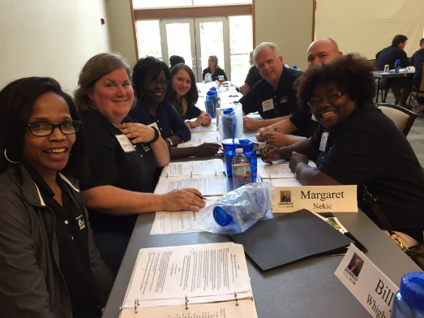 TEAM WORKING ON PROJECT
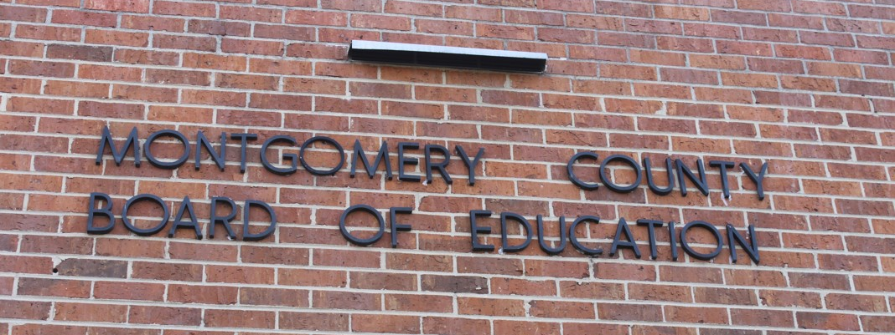
TEAM VISITED MONTGOMERY COUNTY BOARD OF EDUCATION
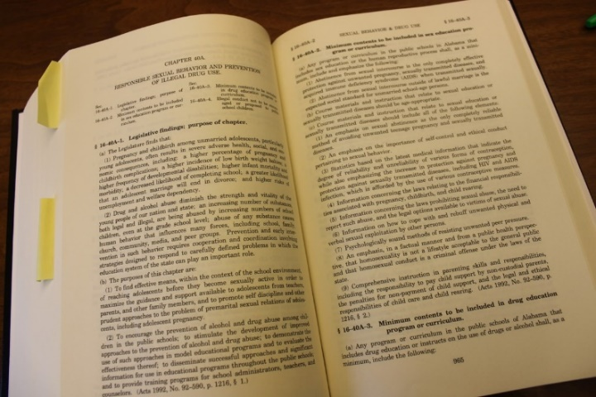 THE LAW
LEGACY CLASS XXXII PROJECT TEAM FIVE

COMMON TECH FOR COMMON GROUND

CHAIR PERSON: “Mighty” Mason Tanaka
TEAM MEMBERS: “Awesome” Allen Farr, “Dapper” David Grizzard, “Energetic” Emily Shade, “Merry” Margaret Nekic, “Remarkable” Rick Shuford, “Smiling” Kyle Kyser and “Turbo” Tobias Mense
THEMATIC AREA: QUALITY OF LIFE/POVERTY AND THE LESS FORTUNATE
PROJECT TEAM 5: Common Ground Montgomery (CGM)
DATE(S) OF IMPLEMENTATION: March 19-23, 2016
DURATION OF THE PROJECT: August 21, 2015 – May 5, 2016
PROJECT LOCATION: Common Ground Montgomery, 1516 Mobile Rd., Montgomery, AL 36108
FINAL PROJECT DESCRIPTION:
To provide improved technology resources and education that will enable Common Ground Montgomery (CGM) to better fulfill their core mission of creating:
…a “safe haven” of love and grace along with structure and discipline for the kids of our neglected and impoverished community. *
*Source: Common Ground Montgomery Mission Statement
MEDIA OUTLETS CONTACTED: Montgomery Advertiser
WHO WAS SERVED AND HOW MANY PEOPLE BENEFITTED?
The community and staff who access CGM. There is a staff of 15 employees and 25 weekly volunteers. There are up to 120 children served and over 500 individuals served through various groups and conferences utilizing the facility.
OTHER AGENCIES AND GROUPS WHO WERE INVOLVED:
Wind Creek, AUM, Service First, Jerry Kyser Builder, Inc., Coastal Insurance Company, DLM Architecture, LLC. – David Mullen, Paxson Design – Bill Paxson, Baptist Health, Karen Goodman, Michael Goodman, Ron Taylor and Nick Palmer.
VISION FOR THE FUTURE OF THE PROJECT: Design and build a sustainable network infrastructure to further advance CGM’s mission that will include ongoing tech support.
PROJECT TEAM FIVE (continued):
WILL THIS BE AN ONGOING PROJECT OR WILL IT BE A ONE-TIME PROJECT?
This one-time project was to install and label the entire Wi-Fi infrastructure. This project included initial acquisition and installation of Wi-Fi access points, routers, software/antivirus and computers. As a bonus, we provided architectural blue prints of CGM. It will be an ongoing project to supplement the hardware, acquisition of devices, and renewal of software/antivirus.
IF IT WILL BE ON-GOING, WHO WILL CARRY THE PROJECT FORWARD?
AUM will provide some first level Helpdesk support at no cost to Common Ground Montgomery. CGM will be responsible for additional equipment purchases and renewal fees.
DESCRIBE EXACTLY HOW YOUR PROJECT WAS IMPLEMENTED:
- Phase I – Define Scope – The purpose for this phase was to determine the needs and requirements of CGM through on-site interviews and an initial facility survey. Additionally, the project team prioritized those requirements, and determined the feasibility of the project team’s execution capacity and capability based on available resources and time.
- Phase II – Gap Analysis – Once the scope was defined, the project team conducted additional site surveys to gather physical inventory of CGM IT resources. The physical inventory is referred to as the “as-is” model. We then conducted a gap analysis by comparing the current state to the future needs of CGM, or the “to-be” model. The resulting gap was the focus of the project.
- Phase III – Implementation – With the gap analysis completed and the requirements finalized, the project team began the actual physical work of installing and labeling a reliable network. In addition, the team upgraded computers and purchased software. Finally, the team provided blue prints to CGM in order to give them a map of the structure for ongoing use.
- Phase IV – Education – The purpose of the final phase of the project was to ensure the CGM staff had the knowledge and capability to maintain as much of the IT infrastructure of the CGM facility as possible. The project team provided hands-on training, as well as educational materials and technical manuals.
- Phase V – Ongoing Support – AUM will provide continued tech help assistance to CGM whenever needed, as long as both entities are in agreement.

HOW MANY VOLUNTEER HOURS WERE DEVOTED TO THIS PROJECT? (Multiply the total number of volunteers by the total number of hours worked, start to finish.)
Activity | # of People | # of Hours | Total
Administration | 3 | 6 | 18
Computer Acquisition | 1 | 2 | 2
Site Visits (4 site visits) | 4 | 8 | 32
Blue Print | 2 | 4 | 8
Team Meetings (8 Meetings @ 1hr) | 8 | 8 | 64
Implementation | 13 | 5 | 65
TOTAL | 31 | 33 | 189

PROJECT TEAM FIVE PHOTOS:
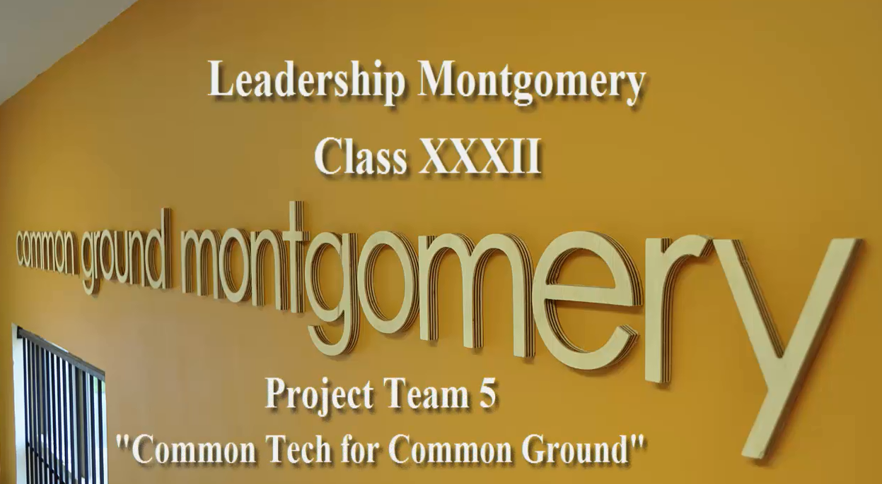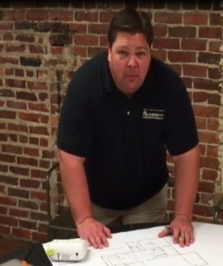

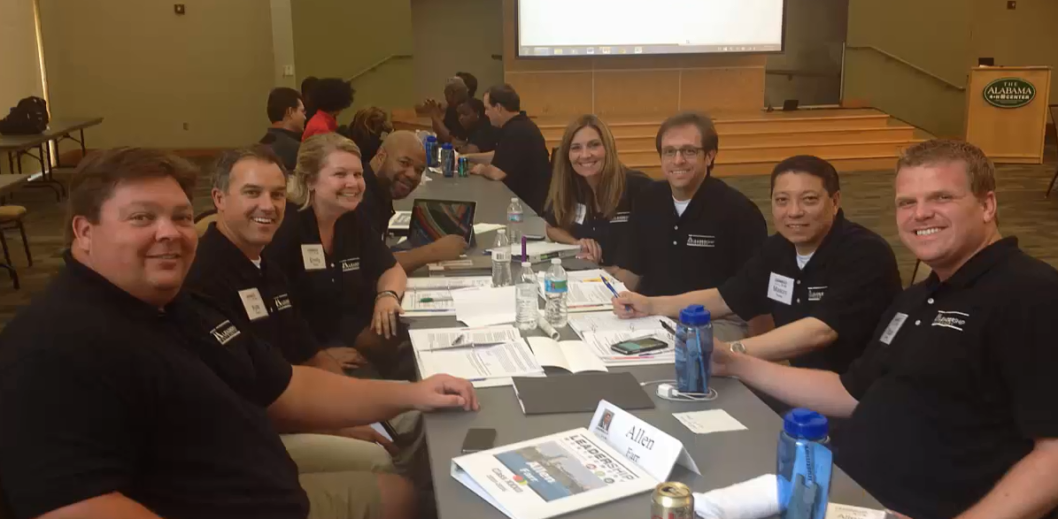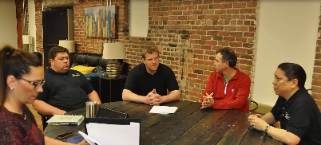

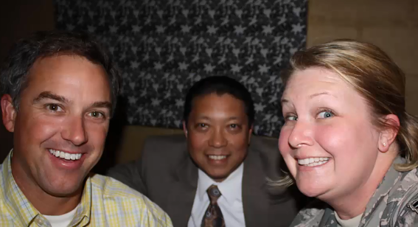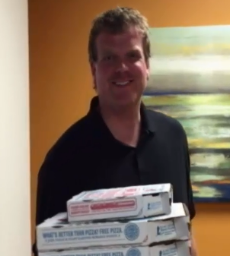

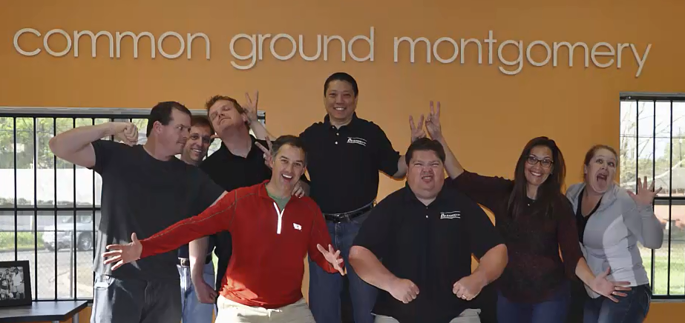

LEGACY CLASS XXXII PROJECT TEAM SIX

TRANSFORMATION MONTGOMERY: THE PATH OUT OF POVERTY

CHAIRPERSON’S NAME: Duane Johnson
TEAM MEMBERS: Christy Anderson, Damon Blythe, Adam Causey, Russ Collier, Duane Johnson, Stacy Reed, Walter Strong
THEMATIC AREA: Quality of Life: Poverty
DATES OF IMPLEMENTATION: October 2015-April 2016
DURATION OF THE PROJECT: 7 Months
LOCATION: Transformation Montgomery, 2625 Lower Wetumpka Rd. Montgomery, AL 36110
FINAL PROJECT DESCRIPTION:
Our project’s goal was to assist Transformation Montgomery in its effort to establish a Transformation Center at the entrance to the Garden Square community located on Lower Wetumpka Road. The Transformation Center is the cornerstone of a program designed to lift the residents of Garden Square out of poverty through rehabilitating abandoned properties and providing enrichment programs for the children and adults of the neighborhood.
In order to assist Transformation Montgomery in this endeavor, our project focused on renovating and refurbishing an arts and music classroom at the Transformation Center. To accomplish this goal, the following actions were taken:
1. Demolition of the existing room structure,
2. Securing a monetary donation for renovation expenses and furnishings for the room,
3. Painting the classrooms,
4. Construction, painting, and installation of four bookshelves,
5. Presentation of a check to Transformation Montgomery.
MEDIA OUTLETS CONTACTED: N/A
WHO WAS SERVED AND HOW MANY PEOPLE BENEFITIED? The project benefits children and parents affiliated with Transformation Montgomery. This group includes the residents of Garden Square, Chisholm, Highland Gardens, and the children attending Chisholm Elementary School.
PROJECT TEAM SIX (continued):
OTHER AGENCIES AND GROUPS WHO WERE INVOLVED:
Our group worked very closely with Transformation Montgomery in the renovation of the room. Numerous volunteers and subcontractors assisted with various phases of the project such as hanging sheet rock, installation of ceiling tile and a cabinet. Assistance was also provided by the following individuals who donated their time:
§ Derek Johnston, Retired, City of Montgomery Real Property Manager, donated his time to assist with demolition of the existing room. His expertise in renovation and construction was invaluable.
§ Clare Watson, City of Montgomery Community Economic Development Coordinator, facilitated initial contact with Debbie Peavy of Transformation Montgomery and donated her time to assist with demolition of the existing room.
§ Richard Anderson, Attorney, donated his time to assist with the demolition of the existing room and construction of four bookshelves that were installed.
§ Jackson Thornton & Co, PC donated $500, which was used for renovation of the room.
VISION FOR THE FUTURE OF THE PROJECT:
The renovation of the Transformation Center, including the arts/music classroom, is just the beginning for Transformation Montgomery. They will continue to acquire and rehabilitate properties in the Garden Square community and then place families who have successfully completed the “Getting Ahead in a Just Getting by World,” a 16-week course and the “Money Matters” course, in the rehabilitated homes. Future plans include a community garden and an aquaponics lab. The arts and music classroom still needs tables and chairs, supplies, and equipment.
WILL THIS BE AN ONGOING PROJECT OR WILL IT BE A ONE-TIME PROJECT?
Furnishing of the room with supplies and seating needs to be completed. The development of the art room is a one-time project, but planning and development of enrichment activities will be ongoing.
IF IT WILL BE ON-GOING, WHO WILL CARRY THE PROJECT FORWARD?
The staff and volunteers of Transformation Montgomery will continue the project. They receive significant support from Frazer United Methodist Church.
DESCRIBE EXACTLY HOW YOUR PROJECT WAS IMPLEMENTED:
We conducted several meetings with Peggy Spaeth, Debbie Peavy, and Rusty Taylor to identify Transformation Montgomery’s greatest need and to identify which project would be most effective. We decided to “adopt” a room in the new Transformation Center and assist Debbie Peavy with her plan of setting up an arts and music room.
PROJECT TEAM SIX (continued):
Phase I was the demolition of the existing room structure, which included ripping out paneling from the walls, demolishing an interior wall, and removing ceiling tiles and insulation.
Phase II included hanging and painting sheet rock in the room. All members of our group participated in Phases I and II of the project.
For Phase III, Adam Causey secured a $500 donation from Jackson Thornton to be used for renovating and refurbishing the room.
Phase IV consisted of purchasing materials for the construction of book cases to be installed in the room. Christy Anderson and Duane Johnson purchased the supplies. Next, Christy and Richard Anderson built the bookcases. Additionally, Christy Anderson, Duane Johnson, Russ Collier, Stacy Reed, and Damon Blythe painted the bookcases and installed them in the room.
Duane Johnson and Stacy Reed coordinated the presentation of a check in the amount of $258.51 to Transformation Montgomery for their use in purchasing tables and chairs for the room. The check was presented on April 14, 2016.
HOW MANY VOLUNTEER HOURS WERE DEVOTED TO THIS PROJECT?
This project utilized 140 volunteer hours.

PROJECT TEAM SIX – PHOTOS:

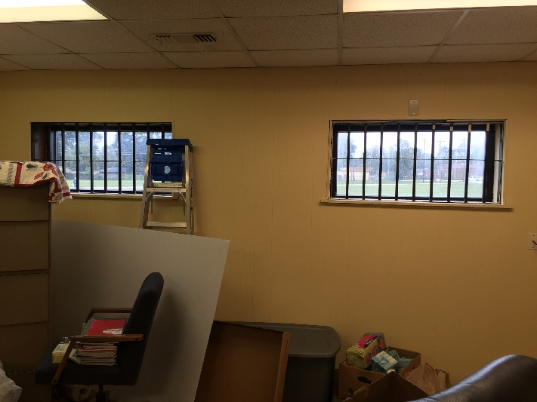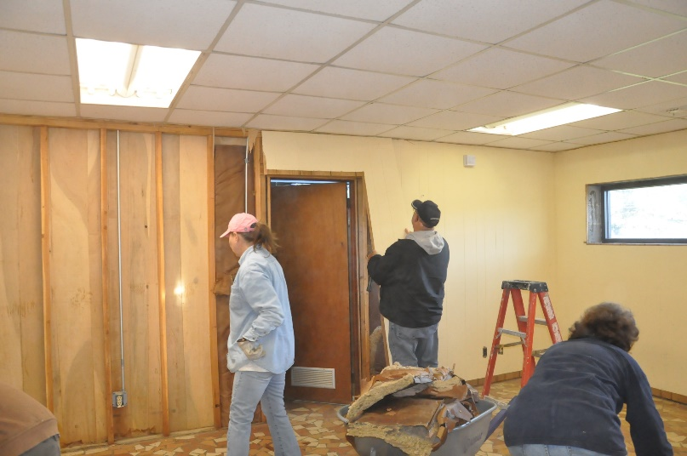
BEFORE DEMOLITION ROOM DEMOLITION

LOGO

PROJECT TEAM SIX PHOTOS:
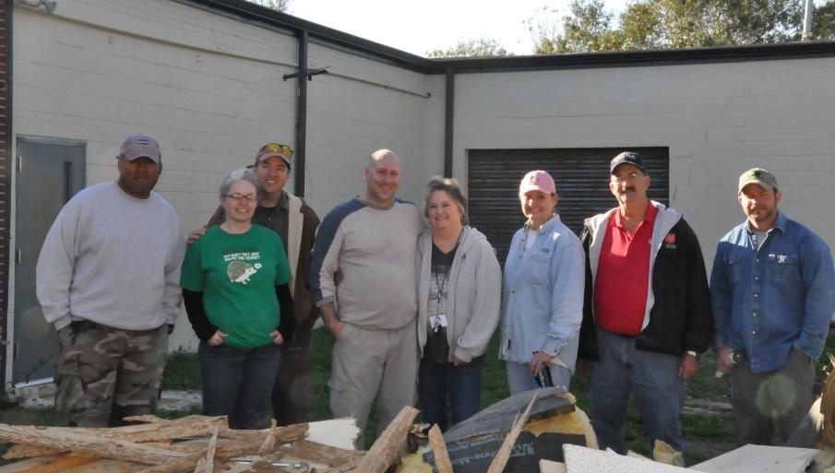
DEMOLITION AFTERMATH

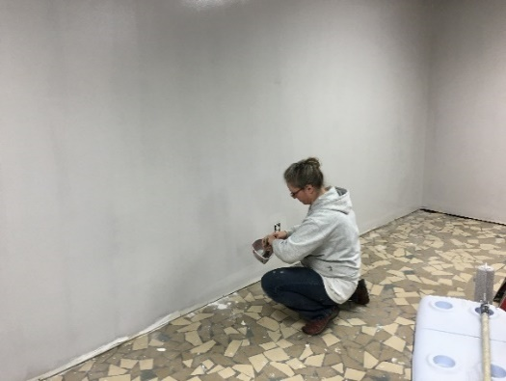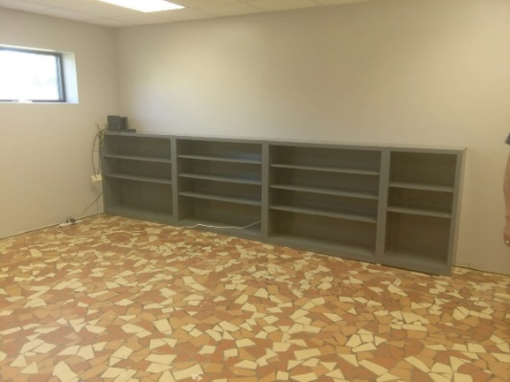
PAINTING THE CLASSROOM INSTALLING SHELVING

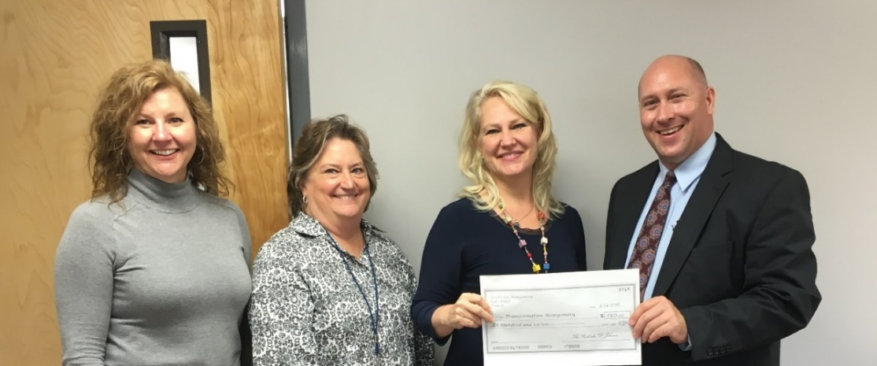
CHECK PRESENTATION
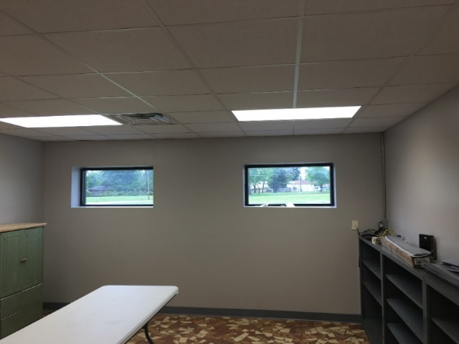 COMPLETED PROJECT
LEGACY CLASS XXXII PROJECT TEAM SEVEN

SUPPORTING ONE PLACE FAMILY JUSTICE CENTER

CHAIR PERSON: Jenny Gola-Smith
TEAM MEMBERS: Jenny Gola-Smith, Charlie Kendall, Elmarko Magee, John McWilliams, Dawn Owens, Ben Venable, and Stephen Woerner
THEMATIC AREA: QUALITY OF LIFE/POVERTY AND THE LESS FORTUNATE
DATE(S) OF IMPLEMENTATION: From September 2015 to May 2016
DURATION OF THE PROJECT: 8 months
PROJECT LOCATION: One Place Family Justice Center; 530 South Lawrence Street; Montgomery, AL 36104
FINAL PROJECT DESCRIPTION:
Located in downtown Montgomery, the One Place Family Justice Center seeks to provide a single venue where victims of family violence can receive all of the assistance that they need. Victims can find an advocate, talk to a police office, receive legal assistance, plan for their physical safety, receive medical assistance, obtain information on shelters, and receive sexual assault services. In essence, One Place serves as an umbrella organization that partners with many other organizations and agencies to provide that support.
From the very beginning, our project focused on learning from the center staff about critical needs for the One Place Family Justice Center to see how our group could support those needs. Based on interviews with Nathan Cook, Executive Director of One Place FJC, we identified three areas of support that defined the vision for our project:
(1) the revitalization of the One Place Family Justice Center website
(2) the production of a promotional video for One Place Family Justice Center
(3) the creation of a model for a sustainable fundraising event.
Through these efforts, we believe that our project has the potential to help the One Place Family Justice Center promote its vision for supporting victims of family violence to the Montgomery area, enhance their online presence, and create more sustainable avenues of fundraising and donor relations throughout the River Region.
MEDIA OUTLETS CONTACTED: None (as of 4/18/2016)
WHO WAS SERVED AND HOW MANY PEOPLE BENEFITTED? At this point, our primary work has directly supported the staff & board of the Family Justice Center. However, we believe that, in time, the website and
PROJECT TEAM SEVEN (continued):
promotional video will have the opportunity to reach thousands of individuals as they learn about the support provided by One Place Family Justice Center to victims of family violence. Furthermore, we believe the creation of a sustainable fundraising event has the potential to create a larger donor base for the center and increased visibility throughout the River Region.
OTHER AGENCIES AND GROUPS WHO WERE INVOLVED:
One Place Family Justice Center Board of Directors (fundraising for video; vision for fundraising event)
G2 Productions (video production)
Revolution MGM (website production)
Capital City Club (location for fundraiser event)
Poarch Band of Creek Indians (funding for food & beverages at fundraising event)
VISION FOR THE FUTURE OF THE PROJECT: We hope that the website and the video will aid in promoting the mission of One Place to the Montgomery community, and we hope that the fundraiser will be a sustainable resource of valuable support for the center and will increase awareness and a potential donor base in the future.
WILL THIS BE AN ONGOING PROJECT OR WILL IT BE A ONE-TIME PROJECT? The promotional video and website revision are one-time projects; we hope that the fundraiser will be ongoing.
IF IT WILL BE ON-GOING, WHO WILL CARRY THE PROJECT FORWARD? The board of One Place Family Justice center will (hopefully) carry the project forward.
DESCRIBE EXACTLY HOW YOUR PROJECT WAS IMPLEMENTED:
In September, our group met with Nathan Cook, Executive Director of One Place, to explore possibilities for our project. At first, we thought we might work with them in creating a clothes closet for victims. We quickly learned in our first tour of the facility that they had recently created this type of resource for victims already, so this really was not a need. However, we did learn about some of the challenges that they were facing as a center.
Those challenges were: promoting the center’s mission to the community and fundraising. Over the course of several meetings in September and October, we started to focus our attention on ways that we could help in those areas. In October, we contacted Joe Bryan at G2 productions to explore the budget needs for a promotional video, and we examined the center’s website to see what improvements could be made.
Specifically, we identified several important needs for the website including the following: maintaining current information about the Board and activities of the center and addressing the ability of FJC staff to easily update the site and support online fundraising.
PROJECT TEAM SEVEN (continued):
A November meeting with DA and FJC Board Chair Darryl Bailey focused on discussing the possibility of creating a fundraising event. Specifically, we brainstormed about creating a sustainable “Walk in Her Shoes” event in which male community leaders would wear high heels on a runway at a cocktail party in downtown Montgomery. We all liked the party idea as a way of increasing funds for the center and an awareness for the mission. We followed the discussion with a meeting with Executive Director Nathan Cook to make sure that he supported the fundraiser; he agreed and invited us to present the idea to the board of the FJC at its December meeting.
In December, members of our group presented the ideas at the monthly FJC Board Meeting to get their endorsement and support for the ideas. We emphasized the need for a board committee to support the fundraiser and shared the fact that we would need the names of potential donors for the promotional video. However, in January the board experienced a transition in board leadership, and by late February, we still had not heard about board support for our project.
In the meantime, we continued to work on conceptualizing a fundraising event. We secured a location and funding for food & beverages and discussed a time and date and decided on May 3, 2016, as the potential date. At the same time we planned a social media rollout and identified potential community leaders to participate in the “walk in her shoes.” In addition, we secured RevolutionMGM to support the revitalization of the One Place website. The goal was for RevolutionMGM to organize a “hack-a-thon” to implement the revisions for the website.
At the FJC Board Meeting in early March, members of our project team presented our specific needs regarding the promotional video and the fundraiser, and we pledged to fill the gap between the funds the board could raise and the total amount needed to implement the project. The board pledged $1000 for the video and agreed to involve our group in its next Marketing Committee Meeting to work through plans for the May fundraiser. (Unfortunately, that meeting has yet to occur.)
In mid-March, we renewed our contact with G2 productions to share the news that money had been raised to begin work on the promotional video. We discussed possible visions for what the video would look like, and a meeting was held in early April with one of the group members and Joe Bryan of G2 productions, Nathan Cook and Michael Briddell, a One Place FJC board member.
We agreed on a vision for the video and a process for interviewing specific individuals on camera to produce the video. Board member Michael Briddell agreed to work on the script for the video, and once the script is completed, filming will begin. Joe Bryan anticipates a two-week turnaround from beginning of filming to the finished product, provided we can consolidate interviews into as few filming days as possible.
Project Results (as of April 18):
- At this point the plans for the website revitalization have been completed after RevolutionMGM hosted the initial brainstorming session on Sunday, April 17, with a completion date scheduled for May 3.
- The script of the video is still being finalized, but the production company is ready to go as soon as the center shares its specific plans. We are working on securing dates for interviews, and we anticipate its completion in early May. However, it may not be ready in time for the project team’s presentation.
PROJECT TEAM SEVEN (continued):
- Regardless of the schedule for completion of the video, we still have the venue reserved for the fundraising event. However, it has not yet been promoted because, as of April 18, we have not received an endorsement from the FJC marketing committee. It is critical that this event have board support and participation to ensure its sustainability. We are hopeful that the event will still occur, but we have to admit that it is possible that there will be a delay. Our team will attend the FJC Board Meeting on April 20 to make final plans for the fundraiser.
HOW MANY VOLUNTEER HOURS WERE DEVOTED TO THIS PROJECT?
Approximately 90 hours so far. There will be more if the fundraising event occurs in May.

PROJECT TEAM SEVEN – PHOTOS
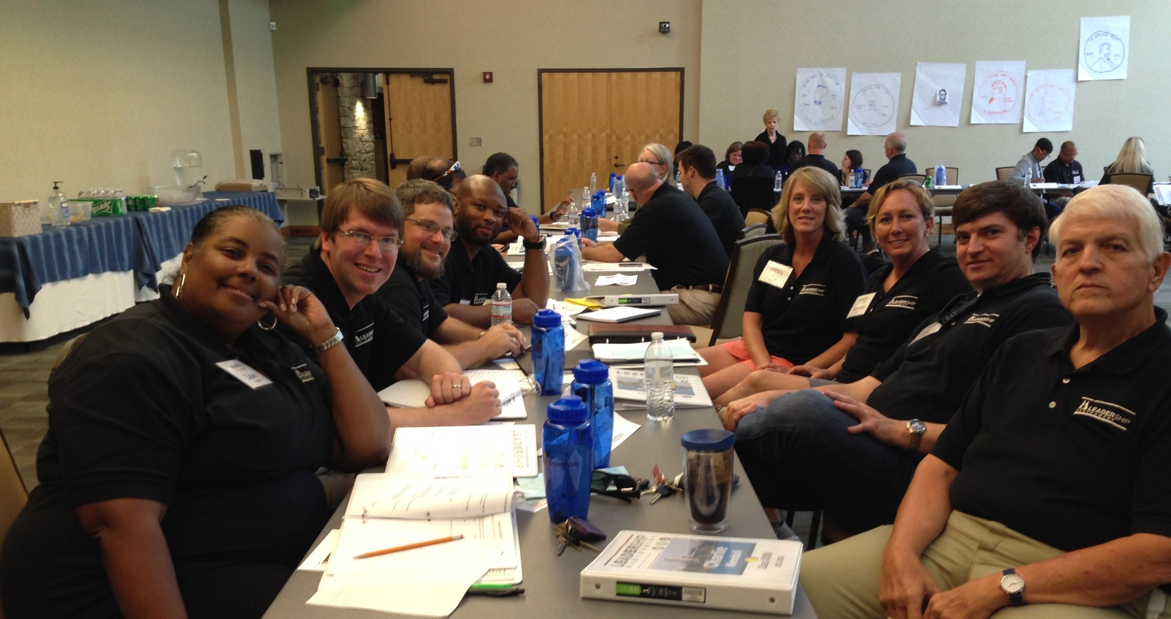
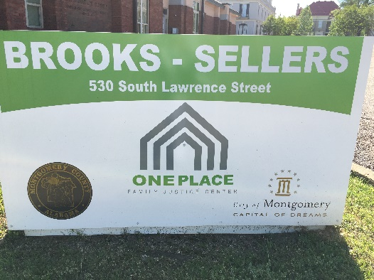 BROOKS SELLERS ONE PLACE 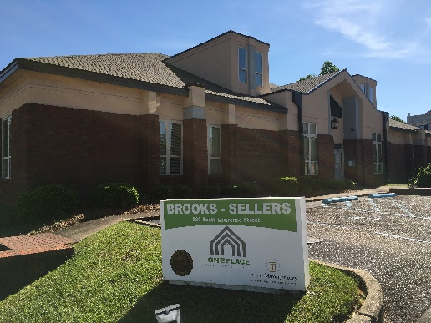

PROJECT TEAM SEVEN PHOTOS:
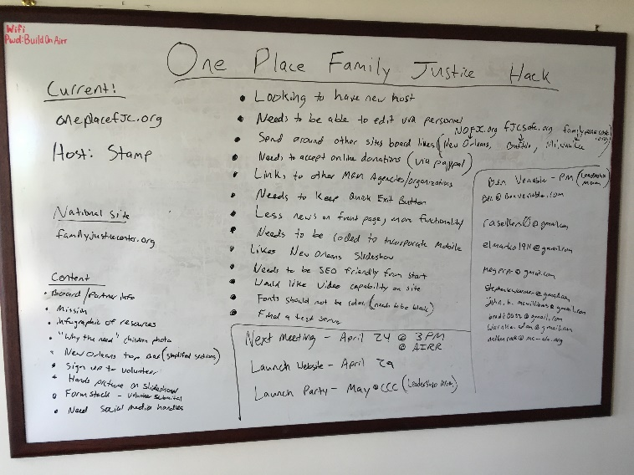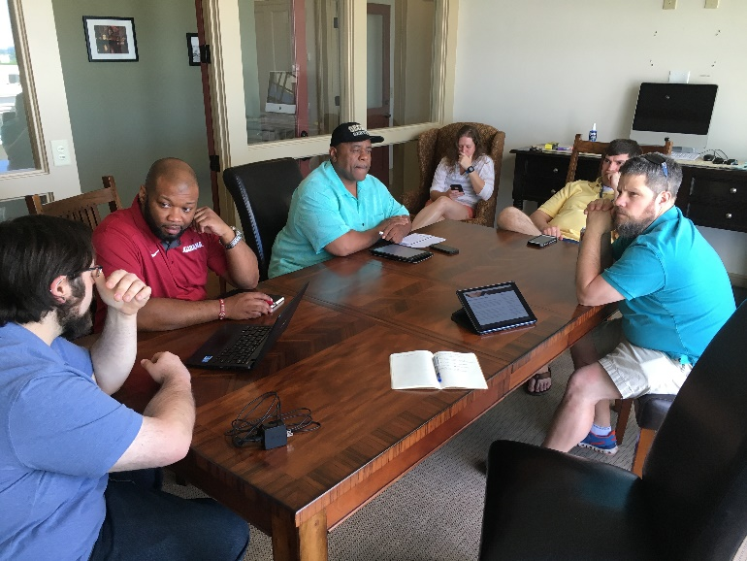
HACKATHON BRAINSTORMING NOTES HACKATHON BRAINSTORMING SESSION
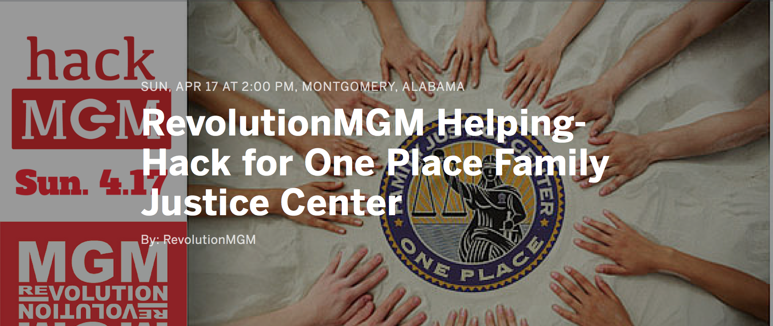
RevolutionMGM Invitation

